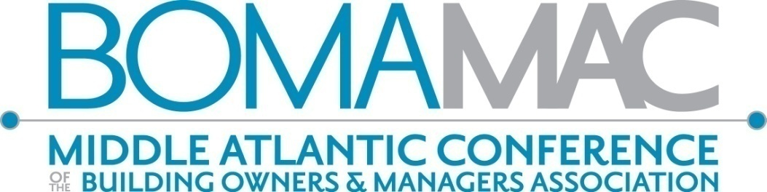

The Middle Atlantic Region, better known as MAC or the Middle Atlantic Conference, is comprised of 14 local associations with a combined membership in excess of 3800 members covering 11 states and the District of Columbia, including: Capital Region/Albany, Baltimore, Boston, Greater Buffalo, Greater Hartford, New Jersey, Philadelphia, Pittsburgh, Long Island, New York, Rochester, Southern Connecticut, AOBA Washington, D.C. and Westchester County, NY, as well as Members at Large.

With so many companies involved with many of the local BOMAs in the MAC Region, we’d like to offer you the opportunity to have your company logo on the MAC web page: [www.bomamac.com](http://www.bomamac.com). Members of the MAC Region will be viewing your logo when they log on to follow MAC and BOMA International events, learn about the Regional and International TOBY judging, etc. We encourage both Principal Members and Allied Members to take this sponsorship, as well as local BOMAs, too.

**A $500.00 sponsorship with your company logo will link to your company’s web page.** The logo will be placed on the home page of the MAC web site. A table-tent with all sponsors’ logos will be on the tables at MAC board meetings and breakfast/lunches at the MAC Conference and BOMA International’s Winter Business Meeting and Summer Convention.

**If you wish to take a sponsorship, please complete the form and send payment to the address below**. **Please send your logo in jpg, tiff, or eps format to executive@bomamac.com.**

Name: _____________________________________________________________________________________________________________

Company: __________________________________________________________________________________________________________

Company’s web site: _______________________________________________________________________________________________

Email: __________________________________________________________ Phone:___________________________________________

Check #:______________________Amt: __________

Please send a check to avoid credit card charges.

Questions?

[executive@bomamac.com](mailto:executive@bomamac.com) for mailing address.

2023 WEB SITE SPONSORSHIP *www.bomamac.com*

ww